**Cable and wires**

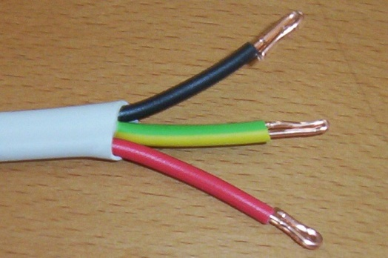Three wires of the same radius are wrapped with a plastic outer layer to form a blue cable.

The cross-section contains four circles shown below.

Find the **ratio** of the total area of the three wires (in red) to the area of empty space (in white) inside the large cable (in blue).

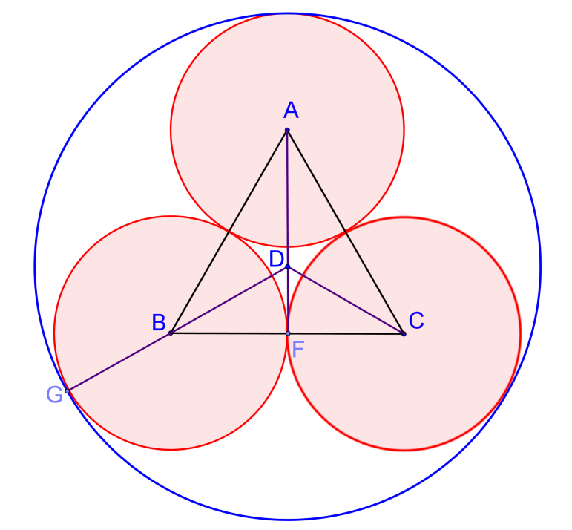**Solution**

As in the diagram in the right, let $A,B,C$ be the centres of the small red circles.

Then $∆ABC$ is an equilateral.

Draw $AF$ perpendicular to $BC$.

Let $D$ be the centre of the outer blue circle.

Draw $DB$ and produce to meet the outer circle at $G$.

For simplicity, let the radii of the three smaller circles be 1.

$∆BDF$ is a $30°-60°-90°$ triangle.

Since $BF=1$, $BD=\frac{1}{\sin{60°}}=\frac{2}{\sqrt{3}}=\frac{2 \sqrt{3}}{3}$

$$DG=BG+BD=1+\frac{2 \sqrt{3}}{3}=\frac{3+2 \sqrt{3}}{3}$$

Area of three smaller red circles $=A_{1}=3π1^{2}=3π$

Area of big blue circle $=π{\left(\frac{3+2 \sqrt{3}}{3}\right)}^{2}=\frac{4 \sqrt{3}+7}{3}π$

Area of empty space (in white) inside the blue cable $=A_{2}=\frac{4 \sqrt{3}+7}{3}π-3π=\frac{4 \sqrt{3}-2}{3}π$

Therefore $A_{1}:A_{2}=3π:\frac{4 \sqrt{3}-2}{3}π=9:\left(4 \sqrt{3}-2\right)=\underline{\underline{1:0.5475781366973}}$

**Yue Kwok Choy**

**1/6/2016**